41.44 Using Eq. 41.4
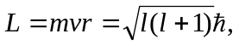
and the Bohr radius from Eq. 38.15, we obtain the following value for
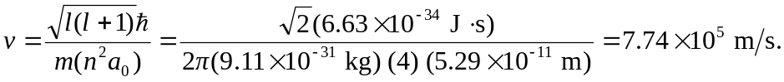
The magnetic field generated by the “moving” proton at the electrons position can be calculated from Eq. 28.1

